Deliverable 1 Modified Scenarios

Xusheng Xiao

000954996

xxiao2@ncsu.edu

# Step 1

Following are sub-scenarios extracted from the problem scenario:

* Sub-scenario 1: MedRes and customer negotiate, and may agree to exchange medical equipment for certain price. *Commercial transaction* pattern models this scenario.
* Sub-scenario 2: MedRes places an order to MedEq and MedEq ships the equipment to customer. *Commercial transaction* pattern models this scenario.
* Sub-scenario 3: MedEq employs a shipper to ship the order (medical equipment) to the customer. *Outsourcing* pattern models this sub-scenario.
* Sub-scenario 4: MedEq buys replenishment stock from a contract manufacturer at a certain price. *Commercial transaction* pattern models this sub-scenario.
* Sub-scenario 5: The contract manufacturer employs a shipper to ship the order (medical equipment) to MedEq. *Outsourcing* pattern models this sub-scenario.
* Sub-scenario 6: Customer requests a support service and MedRes provides the support service for repairing equipment. *Standing service contract* pattern models this scenario.

# Step 2

Following are the roles and the agents adopting those roles for each of the sub-scenarios:

* Sub-scenario 1:

|  |  |
| --- | --- |
| Role | Agent |
| Company | MedRes |
| Customer | A customer of MedRes |

* Sub-scenario 2:

|  |  |
| --- | --- |
| Role | Agent |
| Company | MedRes |
| Customer | A customer of MedEq |
| EqComp | MedEq |

* Sub-scenario 3:

|  |  |
| --- | --- |
| Role | Agent |
| EqComp | MedEq |
| Customer | A customer of MedEq |
| Shipper 1 | FedUp, UpFed |

* Sub-scenario 4:

|  |  |
| --- | --- |
| Role | Agent |
| EqComp | MedEq |
| Manufacturer | FlexMan, SoleMan |

* Sub-scenario 5:

|  |  |
| --- | --- |
| Role | Agent |
| EqComp | MedEq |
| Manufacturer | FlexMan, SoleMan |
| Shipper 2 | A shipper that the manufacturer employs for shipping the order to  MedEq |

* Sub-scenario 6:

|  |  |
| --- | --- |
| Role | Agent |
| Company | MedRes |
| Customer | A customer of MedRes |

# Step 3

Following are the business tasks executed by each role:

* Sub-scenario 1:

|  |  |
| --- | --- |
| Role | Task |
| Company | goodsCust |
| Customer | payComp |

* Sub-scenario 2:

|  |  |
| --- | --- |
| Role | Task |
| Company | payEq |
| EqComp | goodsCust |

* Sub-scenario 3:

|  |  |
| --- | --- |
| Role | Task |
| EqComp | goodsCust, payShip1 |
| Customer |  |
| Shipper 1 | goodsCust |

* Sub-scenario 4:

|  |  |
| --- | --- |
| Role | Task |
| EqComp | payMfg |
| Manufacturer | goodsComp |

* Sub-scenario 5:

|  |  |
| --- | --- |
| Role | Task |
| EqComp |  |
| Manufacturer | goodsComp, payShip2 |
| Shipper 2 | goodsComp |

* Sub-scenario 6:

|  |  |
| --- | --- |
| Role | Task |
| Company | service |
| Customer | payService |

# Step 4

* Sub-scenario 1:

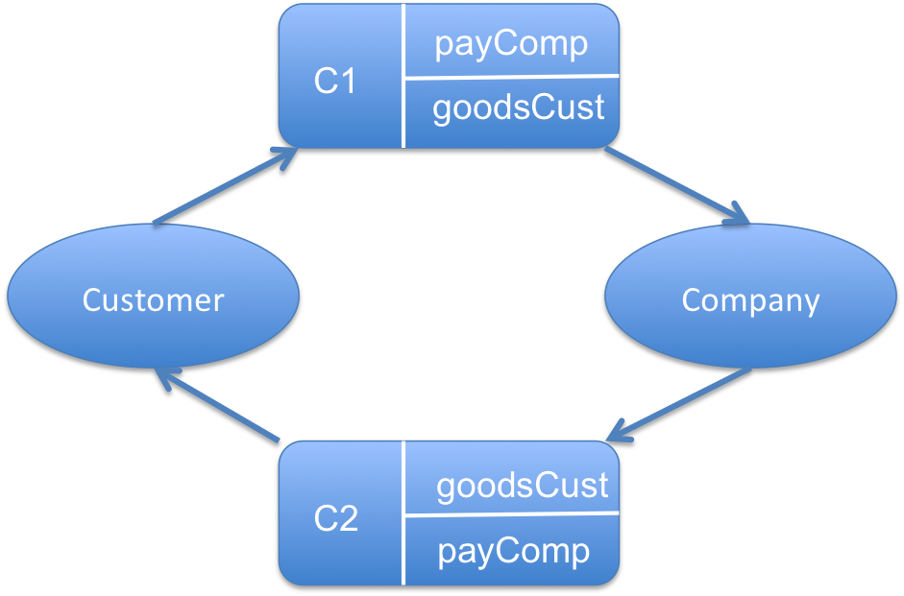

* Sub-scenario 2:

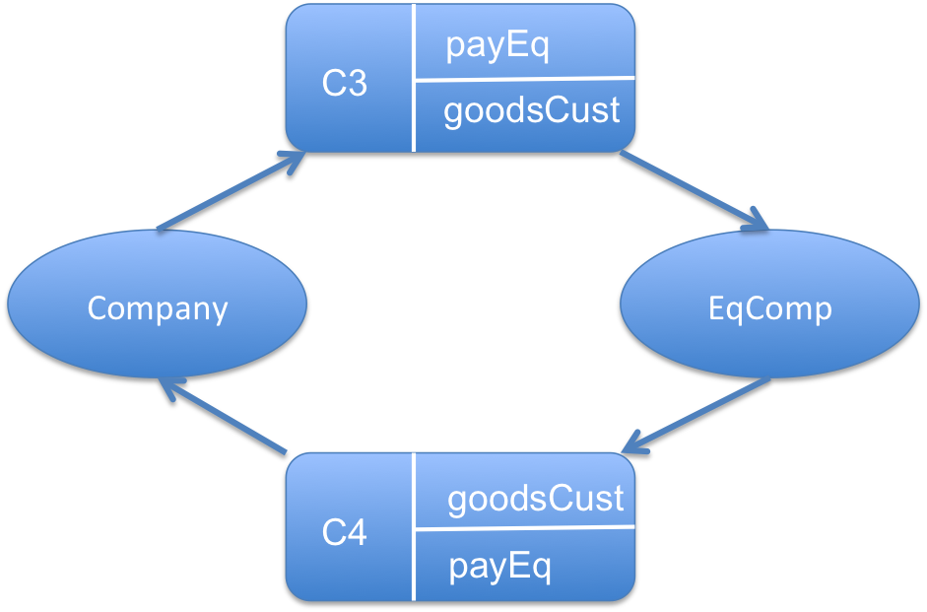

* Sub-scenario 3:

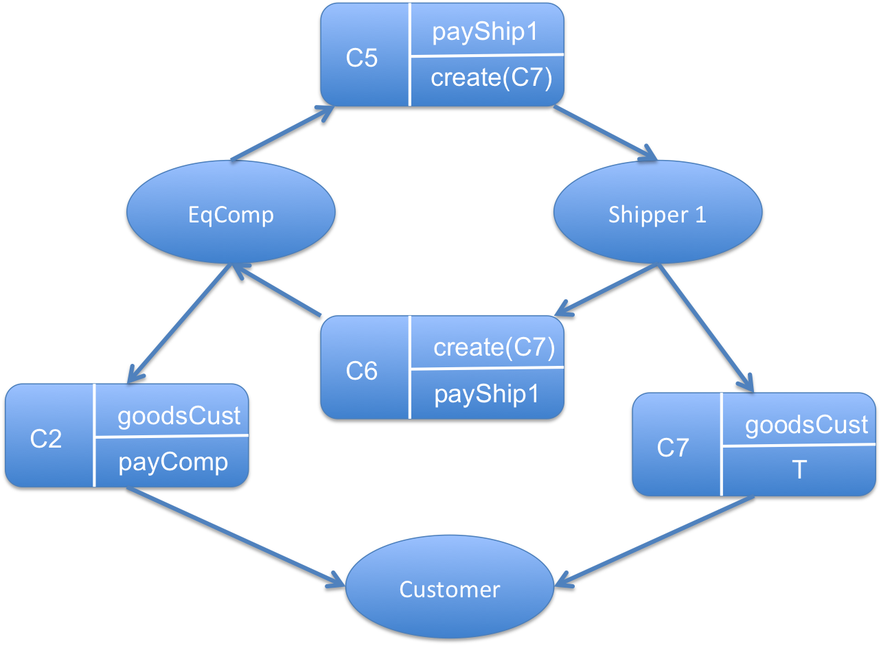

* Sub-scenario 4:

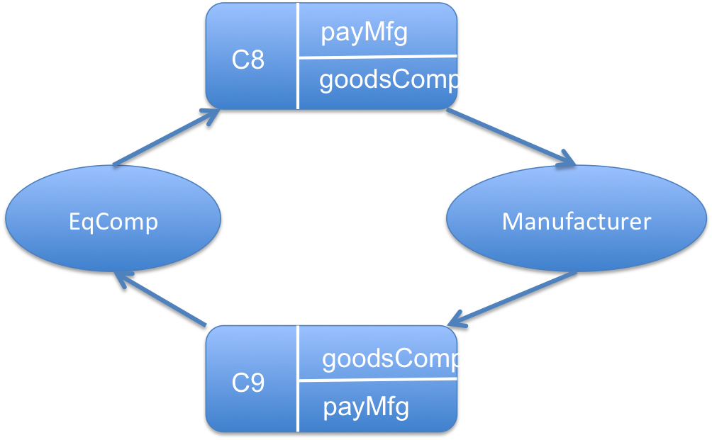

* Sub-scenario 5:

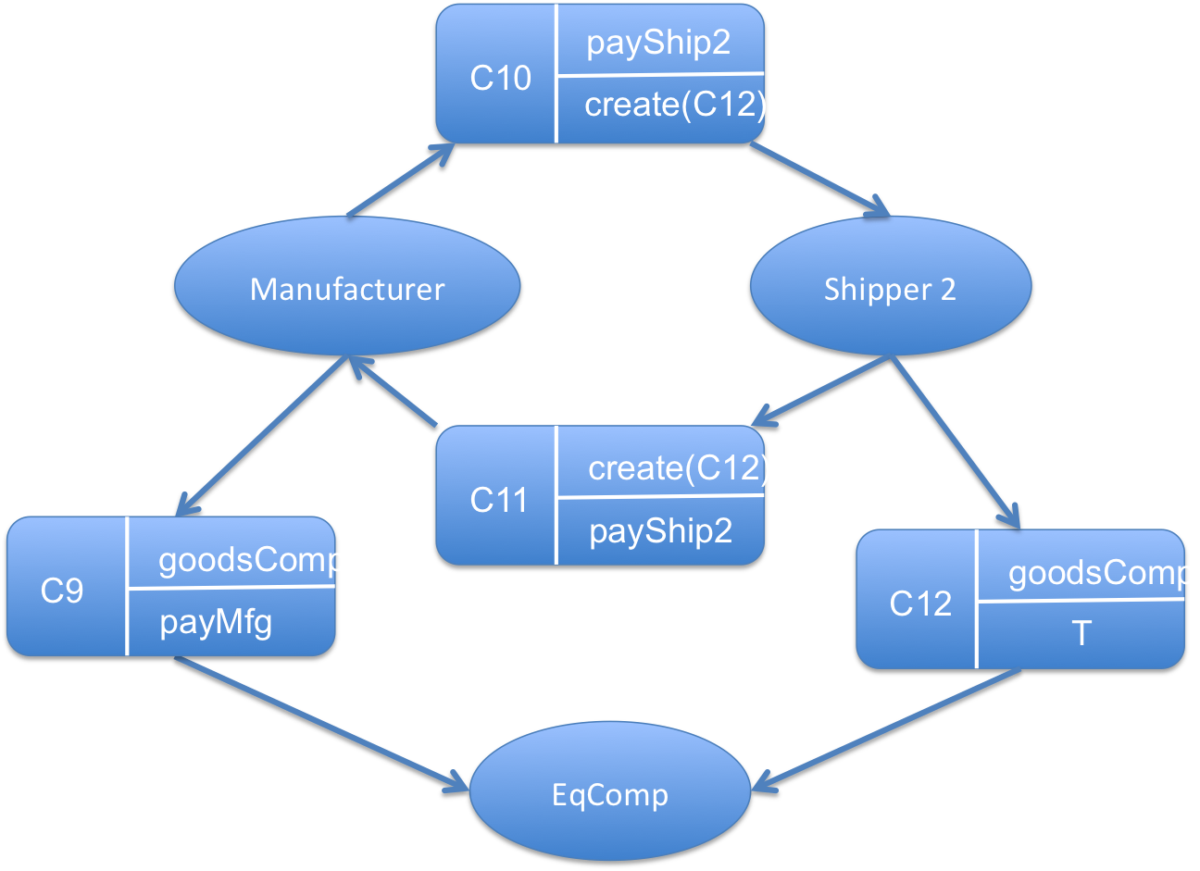

* Sub-scenario 6:

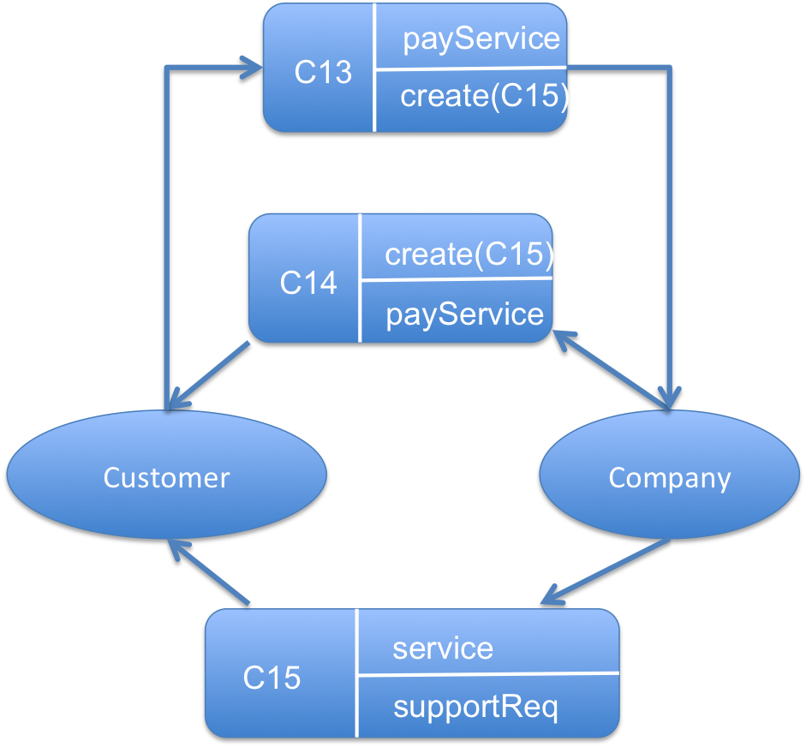

* Business Model:

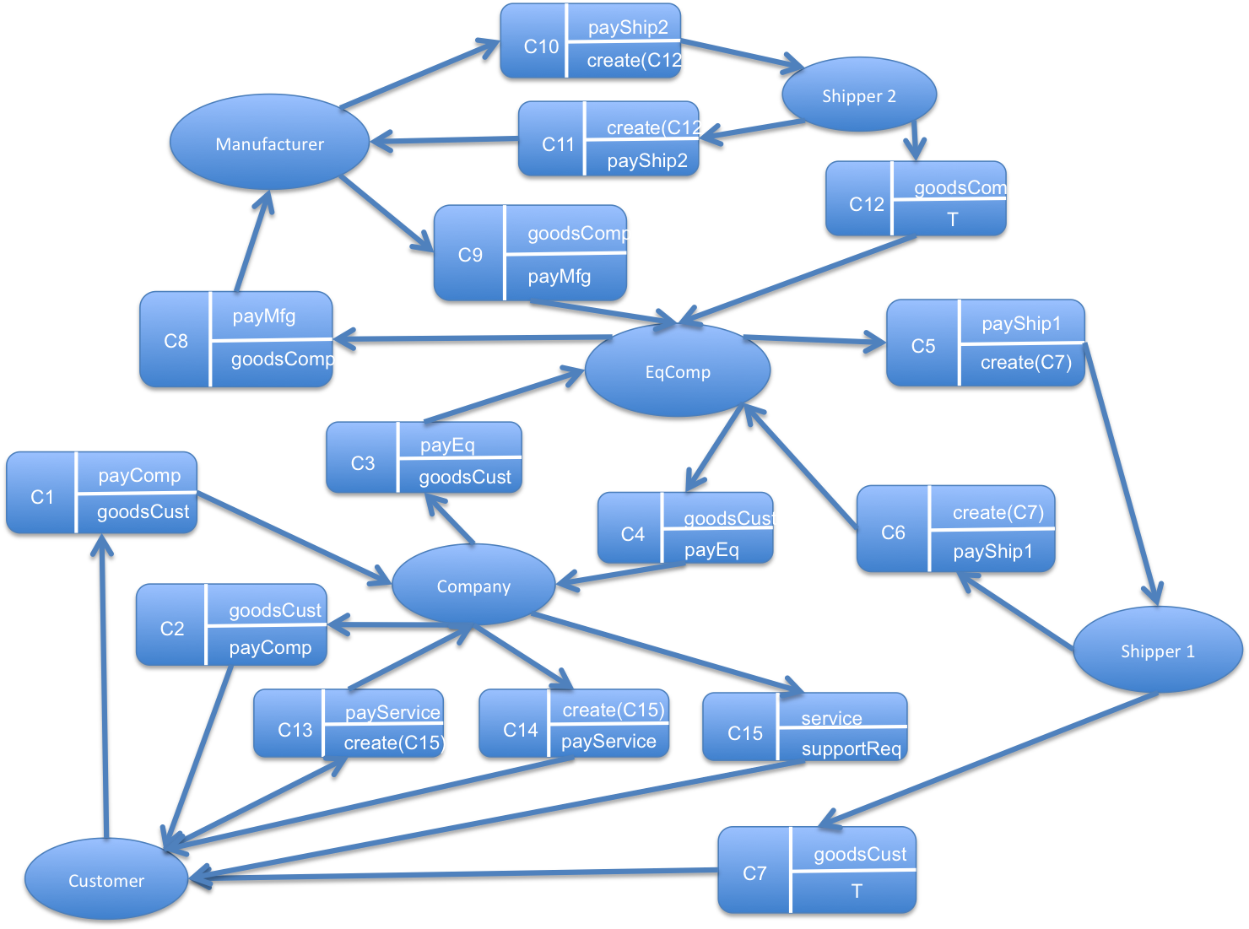

# Step 5

* Sequence diagram for sub-scenario 1,2,3:

|  |  |  |
| --- | --- | --- |
|  |  |  |
| (order) -> create(C3)  (ackOrder) ->create(C4) | (reqShip) -> create(C5)  (ackShipComp) -> create(C6)  (ackShipCust) -> create(C7) |
| **(b) Company places an order to EqComp** | **(c) EqComp requests a shipper to ship**  **the goods (order) to the customer if the**  **goods are in stock** |
|  |  |
| (quote) – create(C1)  (acceptOrder) – create(C2) |  |  |
| **(a) Customer negotiates with company and places an order** |  |  |
|  |  |  |
| **(d) Company pays EqComp for shipping equipment to Customer** | **(e) Company pays EqComp for shipping equipment to Customer** | **(f) Customer pays Company for goods(order)** |

* Sequence diagram for sub-scenario 4 and 5:

|  |  |
| --- | --- |
|  |  |
| (replenishOrder) -> create(C8)  (ackReplenishOrder) -> create(C9) | (reqShip2) -> create(C10)  (ackShipMfg) -> create(C11)  (ackShip2Comp) -> create (C12) |
| **(a) EqComp places a replenishment**  **order with a Manufacturer** | **(b) Manufacturer requests Shipper 2 to**  **ship replenishment order to EqComp** |
|  |  |
| **(b) Manufacturer pays Shipper 2 for shipping replenishment order to EqComp** |  |

* Sequence diagram for sub-scenario 6:

|  |  |
| --- | --- |
|  |  |
| (reqService) -> create(C13)  (ackServiceCust) -> create(C14) | **(b) Customer pays Company for repairing service** |
| **(a) Customer requests repairing service from Company and Company provides service** |  |